**Translation of the logical data model to a physical data model including tables and columns names and data types (SQL Script):**

CREATE TABLE AIRLINE.FREQ_PASSENGER

(

ID NUMBER,

NID NUMBER,

Fname VARCHAR2(12),

Lname VARCHAR2(12),

Address VARCHAR2(100),

Phone VARCHAR2(20)

)

LOGGING

NOCOMPRESS

NOCACHE

NOPARALLEL

NOMONITORING;

ALTER TABLE AIRLINE.FREQ_PASSENGER ADD (

CONSTRAINT FREQ_PASSENGER_PK

PRIMARY KEY

(ID));

---------------------------------------

CREATE TABLE AIRLINE.Flight

(

ID NUMBER,

FLIGHT_KEY NUMBER,

Departure_Airport VARCHAR2(20),

Arrival_Airport VARCHAR2(20),

Departure_Time DATE,

Arrival Time DATE

)

LOGGING

NOCOMPRESS

NOCACHE

NOPARALLEL

NOMONITORING;

ALTER TABLE AIRLINE.Flight ADD (

CONSTRAINT Flight_PK

PRIMARY KEY

(ID));

---------------------------------------

CREATE TABLE AIRLINE.Class

(

ID NUMBER,

Class_type VARCHAR2(20)

)

LOGGING

NOCOMPRESS

NOCACHE

NOPARALLEL

NOMONITORING;

ALTER TABLE AIRLINE.Class ADD (

CONSTRAINT Class_PK

PRIMARY KEY

(ID));

---------------------------------------

CREATE TABLE AIRLINE.Date_table

(

KEY NUMBER,

full_Date DATE,

Full_day_desc VARCHAR2(100),

Day_of_week NUMBER,

Day_of_month NUMBER,

Day_of_year NUMBER,

Last_day_of_month VARCHAR2(20),

Month_name VARCHAR2(20),

Day_name VARCHAR2(20),

quarter NUMBER,

year NUMBER,

Half_year NUMBER

)

LOGGING

NOCOMPRESS

NOCACHE

NOPARALLEL

NOMONITORING;

ALTER TABLE AIRLINE.Date_table ADD (

CONSTRAINT Date_PK

PRIMARY KEY

(KEY));

-------------------------------------------

CREATE TABLE AIRLINE.Passenger

(

ID NUMBER,

N_ID NUMBER,

Fname VARCHAR2(20),

Lname VARCHAR2(20),

Address VARCHAR2(50),

Phone_number VARCHAR2(50)

)

LOGGING

NOCOMPRESS

NOCACHE

NOPARALLEL

NOMONITORING;

ALTER TABLE AIRLINE.Passenger ADD (

CONSTRAINT Passenger_PK

PRIMARY KEY

(ID));

-------------------------------------------

CREATE TABLE AIRLINE.Fare_basis

(

ID NUMBER,

Code VARCHAR2(50)

)

LOGGING

NOCOMPRESS

NOCACHE

NOPARALLEL

NOMONITORING;

ALTER TABLE AIRLINE.Fare_basis ADD (

CONSTRAINT Fare_base_PK

PRIMARY KEY

(ID));

----------------------------------------------

CREATE TABLE AIRLINE.Reservation_Channel

(

ID NUMBER,

TYPE VARCHAR2(100)

)

LOGGING

NOCOMPRESS

NOCACHE

NOPARALLEL

NOMONITORING;

ALTER TABLE AIRLINE.Reservation_Channel ADD (

CONSTRAINT Reservation_Channel_PK

PRIMARY KEY

(ID));

----------------------------------------------

CREATE TABLE AIRLINE.Hotel

(

ID NUMBER,

NAME VARCHAR2(100),

CITY VARCHAR2(50),

COUNTRY VARCHAR2(50)

)

LOGGING

NOCOMPRESS

NOCACHE

NOPARALLEL

NOMONITORING;

ALTER TABLE AIRLINE.Hotel ADD (

CONSTRAINT Hotel_PK

PRIMARY KEY

(ID));

------------------------------------------------

CREATE TABLE AIRLINE.Cust_Opinion

(

ID NUMBER,

Type VARCHAR2(50),

Description VARCHAR2(300)

)

LOGGING

NOCOMPRESS

NOCACHE

NOPARALLEL

NOMONITORING;

ALTER TABLE AIRLINE.Cust_Opinion ADD (

CONSTRAINT Cust_Opinion_PK

PRIMARY KEY

(ID));

-----------------------------------------------

CREATE TABLE AIRLINE.Interaction

(

ID NUMBER,

TYPE VARCHAR2(50)

)

LOGGING

NOCOMPRESS

NOCACHE

NOPARALLEL

NOMONITORING;

ALTER TABLE AIRLINE.Interaction ADD (

CONSTRAINT Interaction_PK

PRIMARY KEY

(ID));

-----------------------------------------------

CREATE TABLE AIRLINE.FLIGHT_ACTIVITY

(

FLIGHT_ID NUMBER,

PASSENGER_ID NUMBER,

DATE_ID NUMBER,

FARE_BASIS_ID NUMBER,

RESERVATION_CHANNEL_ID NUMBER,

CLASS_ID NUMBER,

DISTANCE_IN_MILES NUMBER,

MILES_EARNED NUMBER

)

LOGGING

NOCOMPRESS

NOCACHE

NOPARALLEL

NOMONITORING;

ALTER TABLE AIRLINE.FLIGHT_ACTIVITY ADD (

FOREIGN KEY (CLASS_ID)

REFERENCES AIRLINE.CLASS (ID),

FOREIGN KEY (FLIGHT_ID)

REFERENCES AIRLINE.FLIGHT (ID),

FOREIGN KEY (PASSENGER_ID)

REFERENCES AIRLINE.FREQ_PASSENGER (ID),

FOREIGN KEY (DATE_ID)

REFERENCES AIRLINE.DATE_TABLE (KEY),

FOREIGN KEY (FARE_BASIS_ID)

REFERENCES AIRLINE.FARE_BASIS (ID),

FOREIGN KEY (RESERVATION_CHANNEL_ID)

REFERENCES AIRLINE.RESERVATION_CHANNEL (ID));

--------------------------------------------

CREATE TABLE AIRLINE.PASSENGER

(

ID NUMBER,

NID VARCHAR2(20),

FNAME VARCHAR2(20),

LNAME VARCHAR2(20),

ADDRESS VARCHAR2(100),

PHONE VARCHAR2(20)

)

LOGGING

NOCOMPRESS

NOCACHE

NOPARALLEL

NOMONITORING;

ALTER TABLE AIRLINE.PASSENGER ADD (

CONSTRAINT PASSENGER_PK

PRIMARY KEY

(ID));

----------------------------------------------

CREATE TABLE AIRLINE.Reservation

(

DATE_ID NUMBER,

PASSENGER_ID NUMBER,

FLIGHT_ID NUMBER,

RESERVATION_CHANNEL_ID NUMBER,

CLASS_ID NUMBER,

RESERVATION_ID NUMBER,

SEAT NUMBER,

RATE NUMBER,

PAYMENT_AMOUNT NUMBER

)

LOGGING

NOCOMPRESS

NOCACHE

NOPARALLEL

NOMONITORING;

ALTER TABLE AIRLINE.Reservation ADD (

CONSTRAINT Reservation_PK

PRIMARY KEY

(RESERVATION_ID));

ALTER TABLE AIRLINE.Reservation ADD (

FOREIGN KEY (DATE_ID)

REFERENCES AIRLINE.DATE_TABLE (KEY),

FOREIGN KEY (FLIGHT_ID)

REFERENCES AIRLINE.FLIGHT (ID),

FOREIGN KEY (RESERVATION_CHANNEL_ID)

REFERENCES AIRLINE.RESERVATION_CHANNEL (ID),

FOREIGN KEY (PASSENGER_ID)

REFERENCES AIRLINE.PASSENGER (ID),

FOREIGN KEY (CLASS_ID)

REFERENCES AIRLINE.CLASS (ID));

-----------------------------------------

CREATE TABLE AIRLINE.OVERNIGHT_STAYS

(

Date_of_Arrival_Key NUMBER,

Date_of_Departure_Key NUMBER,

Date_of_Reservation_Key NUMBER,

Passenger_ID NUMBER,

HOTEL_ID NUMBER,

Reservation_Channel_ID NUMBER,

TICKET_NUMBER NUMBER,

Number_of_Nights NUMBER

)

LOGGING

NOCOMPRESS

NOCACHE

NOPARALLEL

NOMONITORING;

ALTER TABLE AIRLINE.OVERNIGHT_STAYS ADD (

FOREIGN KEY (Date_of_Arrival_Key)

REFERENCES AIRLINE.DATE_TABLE (KEY),

FOREIGN KEY (Date_of_Departure_Key)

REFERENCES AIRLINE.DATE_TABLE (KEY),

FOREIGN KEY (Date_of_Reservation_Key)

REFERENCES AIRLINE.DATE_TABLE (KEY),

FOREIGN KEY (Passenger_ID)

REFERENCES AIRLINE.FREQ_PASSENGER (ID),

FOREIGN KEY (HOTEL_ID)

REFERENCES AIRLINE.HOTEL (ID),

FOREIGN KEY (Reservation_Channel_ID)

REFERENCES AIRLINE.RESERVATION_CHANNEL (ID));

--------------------------------------------

CREATE TABLE AIRLINE.Customer_care

(

DATE_KEY NUMBER,

PASSENGER_ID NUMBER,

FLIGHT_ID NUMBER,

OPINION_ID NUMBER,

INTERACTION_ID NUMBER,

PROBLEM_SEVERITY NUMBER,

FEEDBACK_RATE NUMBER

)

LOGGING

NOCOMPRESS

NOCACHE

NOPARALLEL

NOMONITORING;

ALTER TABLE AIRLINE.Customer_care ADD (

FOREIGN KEY (DATE_KEY)

REFERENCES AIRLINE.DATE_TABLE (KEY),

FOREIGN KEY (PASSENGER_ID)

REFERENCES AIRLINE.PASSENGER (ID),

FOREIGN KEY (FLIGHT_ID)

REFERENCES AIRLINE.FLIGHT (ID),

FOREIGN KEY (OPINION_ID)

REFERENCES AIRLINE.CUST_OPINION (ID),

FOREIGN KEY (INTERACTION_ID)

REFERENCES AIRLINE.INTERACTION (ID));

--------------------------------------------

**sample data used in queries:**

we have used **dbForge Data Generator for Oracle** tool to auto generate dummy data.

FLIGHT_ACTIVITY

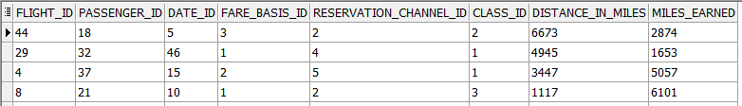

RESERVATION

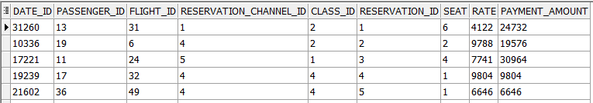

CUSTOMER_CARE

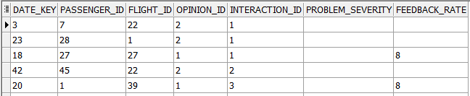

OVERNIGHT_STAYS

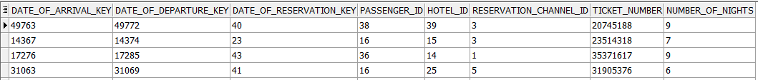

FREQ_PASSENGER

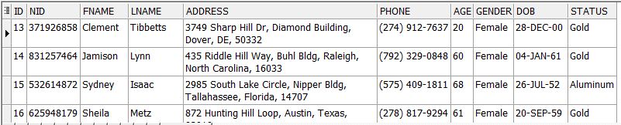

FLIGHT

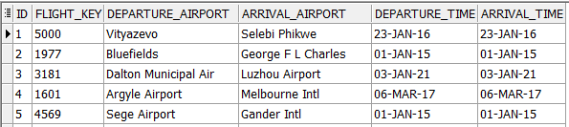

RESERVATION_CHANNEL

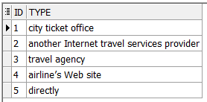

FARE_BASIS

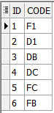

DATE_TABLE

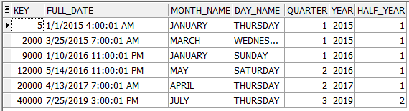

CLASS

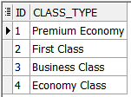

PASSENGER

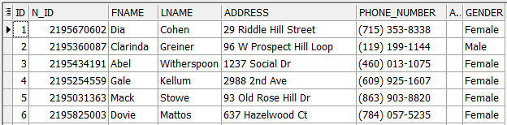

CUST_OPINION

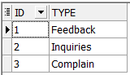

INTERACTION

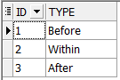

HOTEL

